Name: Gail Chapman
Course: Beginning programming

Lesson Plan: Create and program a cricket car using Lego PicoCricket kits

Students will create their own cricket car. Students can use the example from http://www.picocricket.com/motion.html and add any additional features to make it their own.

Design requirements. The car must be able to move forward and backward upon some command. You can follow the design of the cricket car example and add details to it

Programming Specifications: The car must move forward and backward on some command (clap, touch, sound, etc.) The car must have lights, sound. Must use all four of the Pico Cricket ports.

Documentation: Flowchart of the program must be written or typed and turned in.

Pictures of student work below. The students loved this project. They were very inventive and creative.

Content of what is taught | Students will use basic programming techniques to design, implement, and solve simple problems using an object-oriented programming language
Standards | MM3P1. Students will solve problems (using appropriate technology).  ELA11W1 The  BCS-BP-6. Students will design solutions for simple programs using basic programming techniques and constructs.  BCS-BP-5. Students will design algorithms and programming solutions for a variety of computational problems.
Software Title | PicoBlocks from Lego
Student Assessment | Rubric
Pre Lesson | Students will become familiar with the PicoBlocks by completing the activities that come with the PicoCricket Kit.
Lesson Goals | Introduce programming concepts while stimulating creative thinking, and engaging students in learning. Students will design a car from Legos and program it

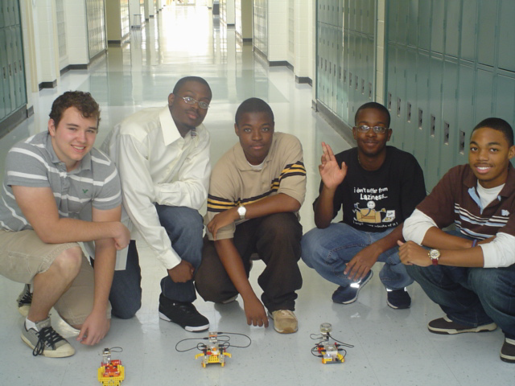
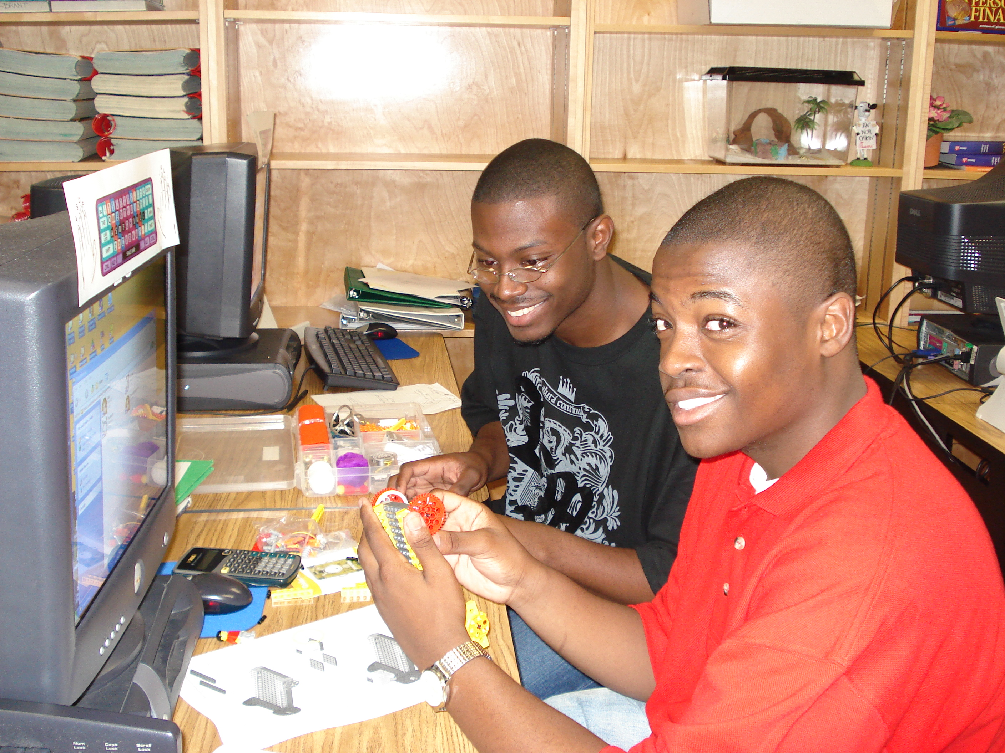
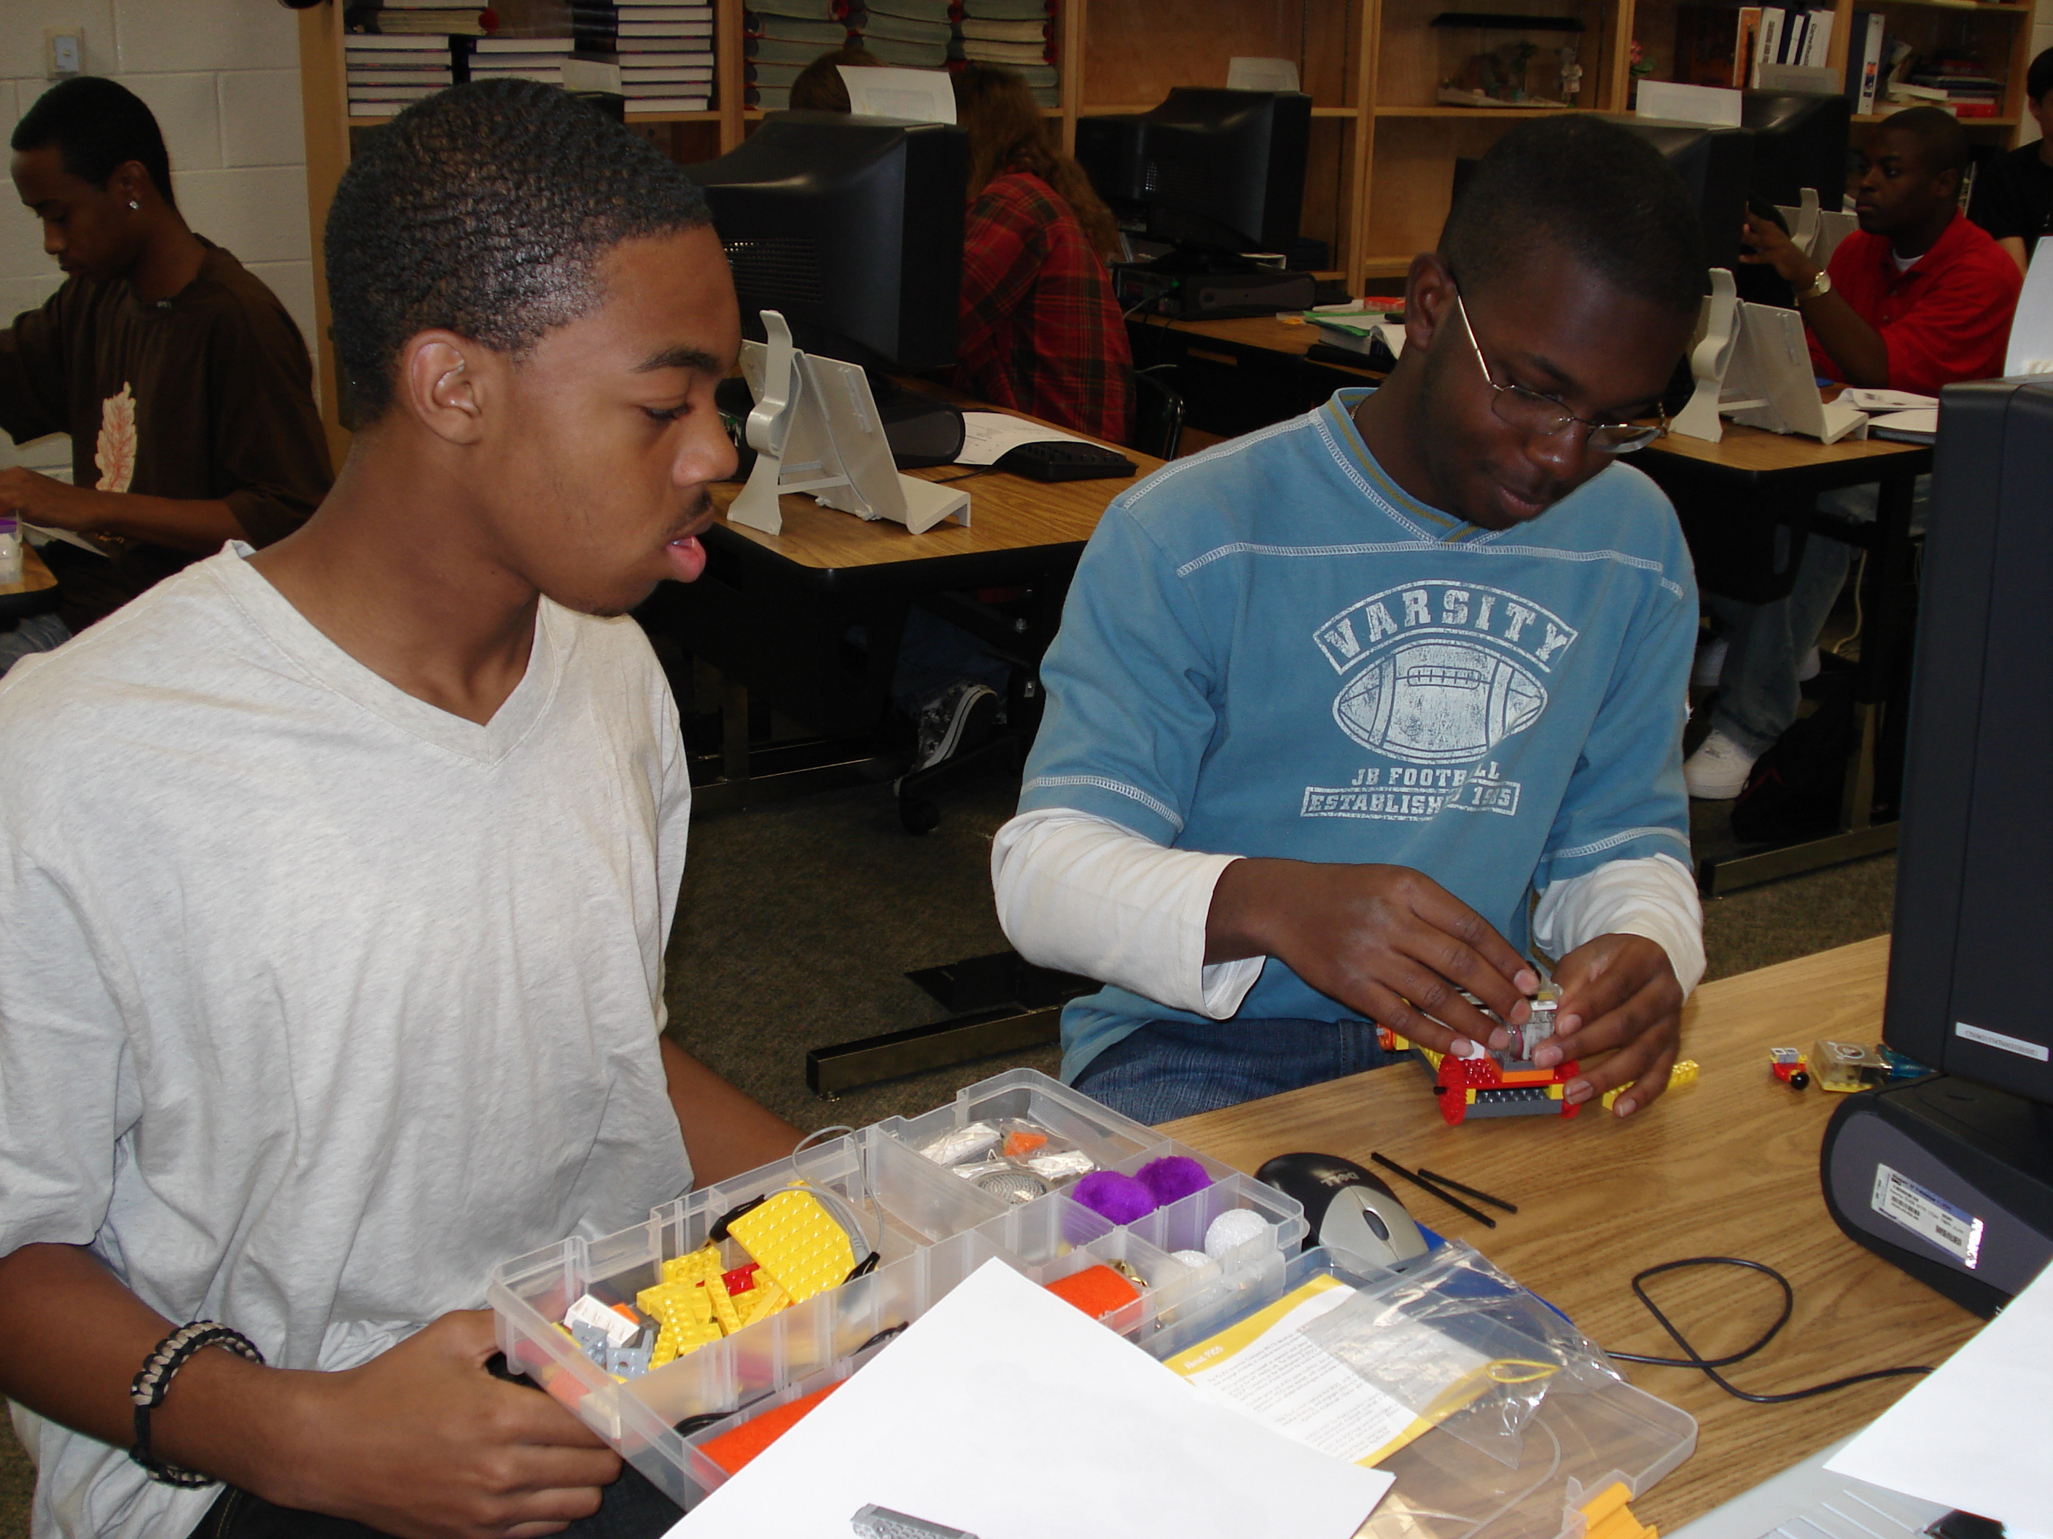
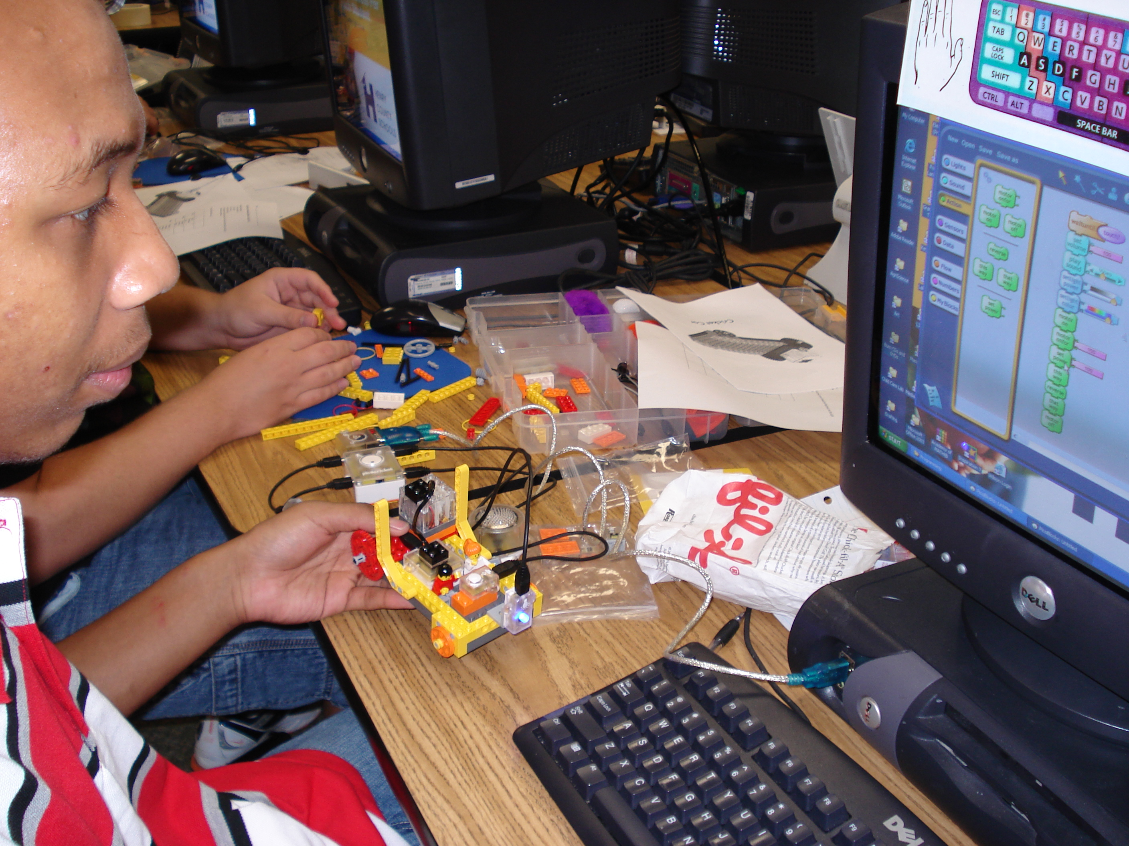
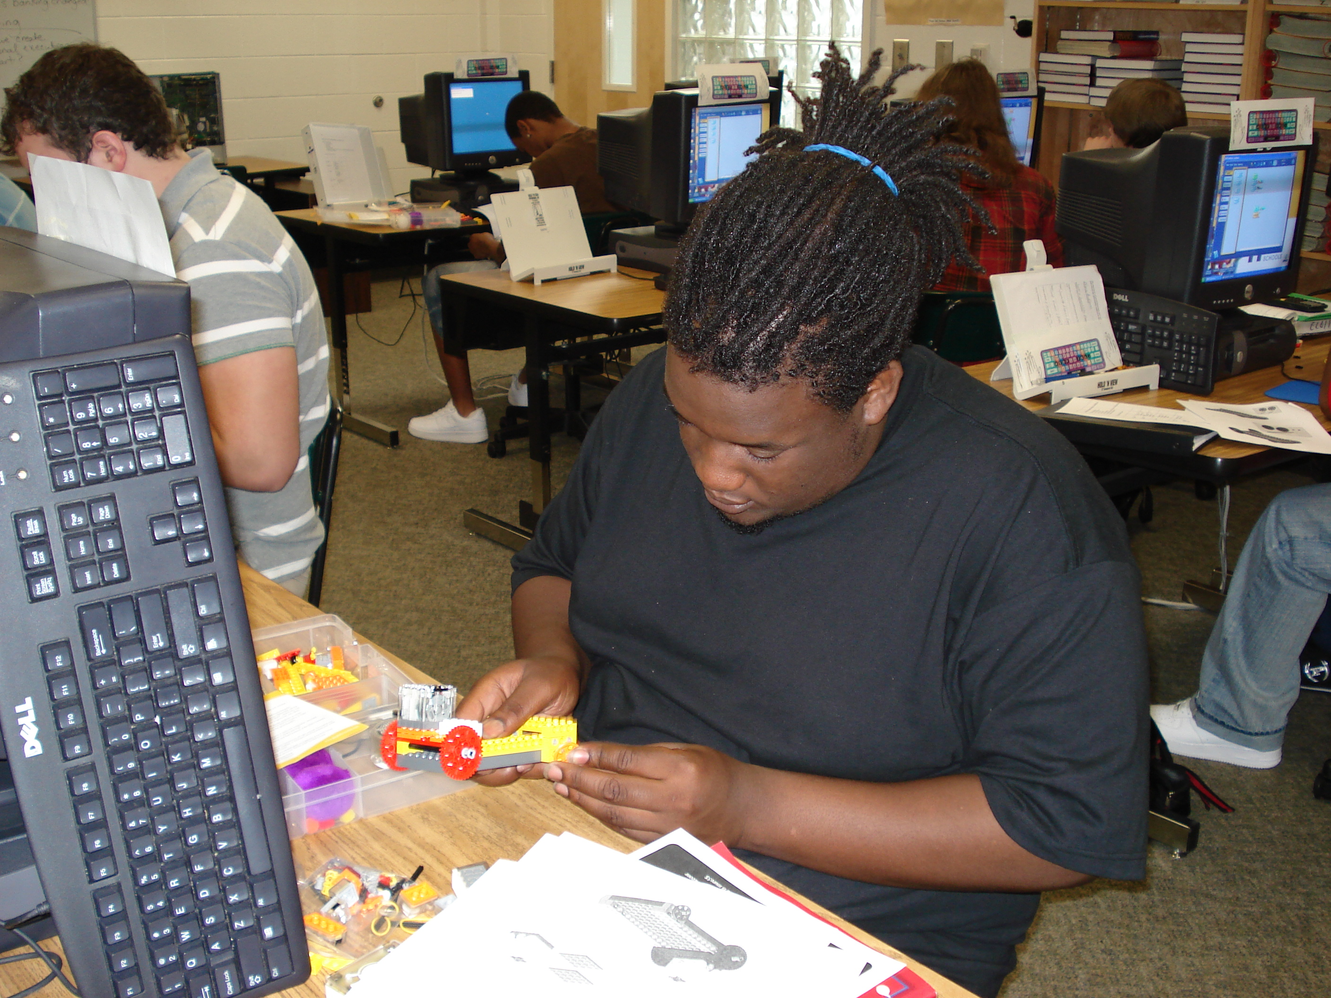

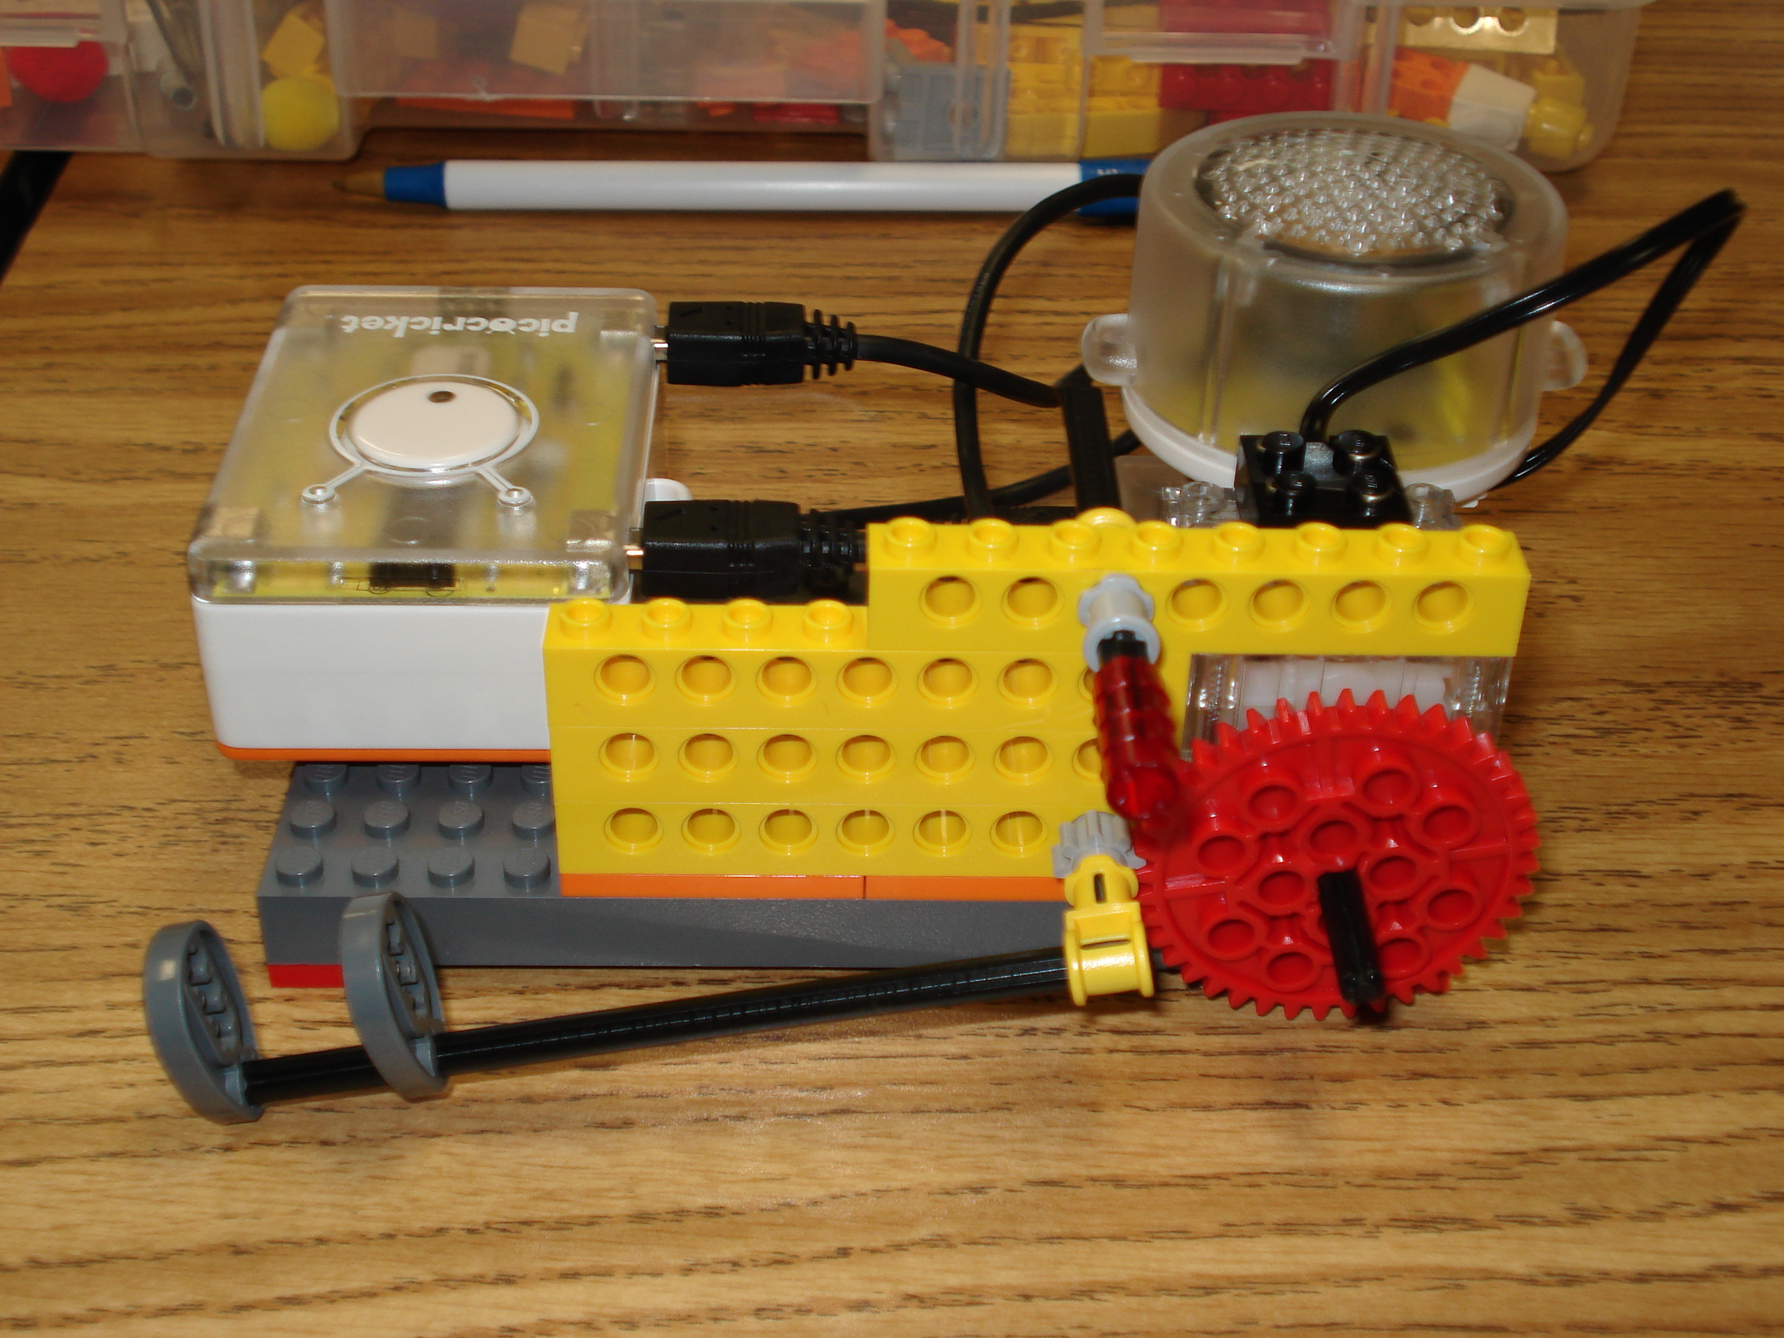
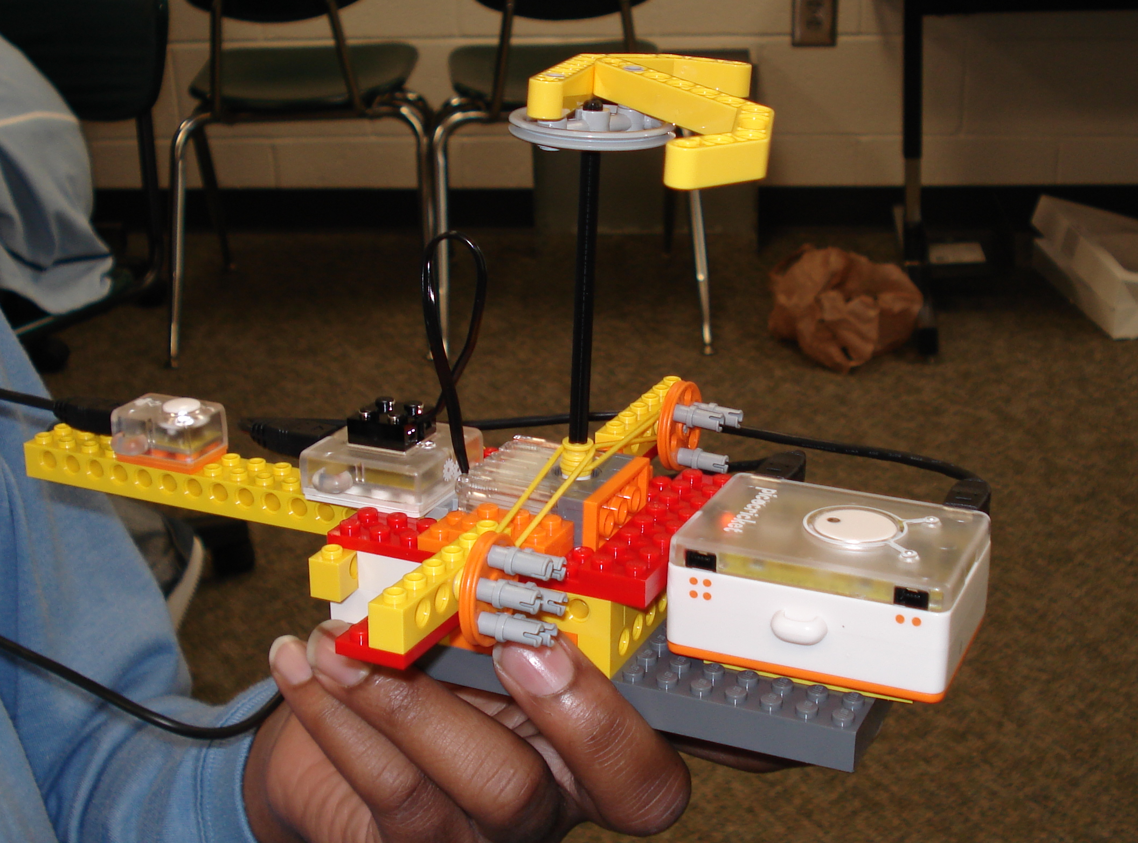
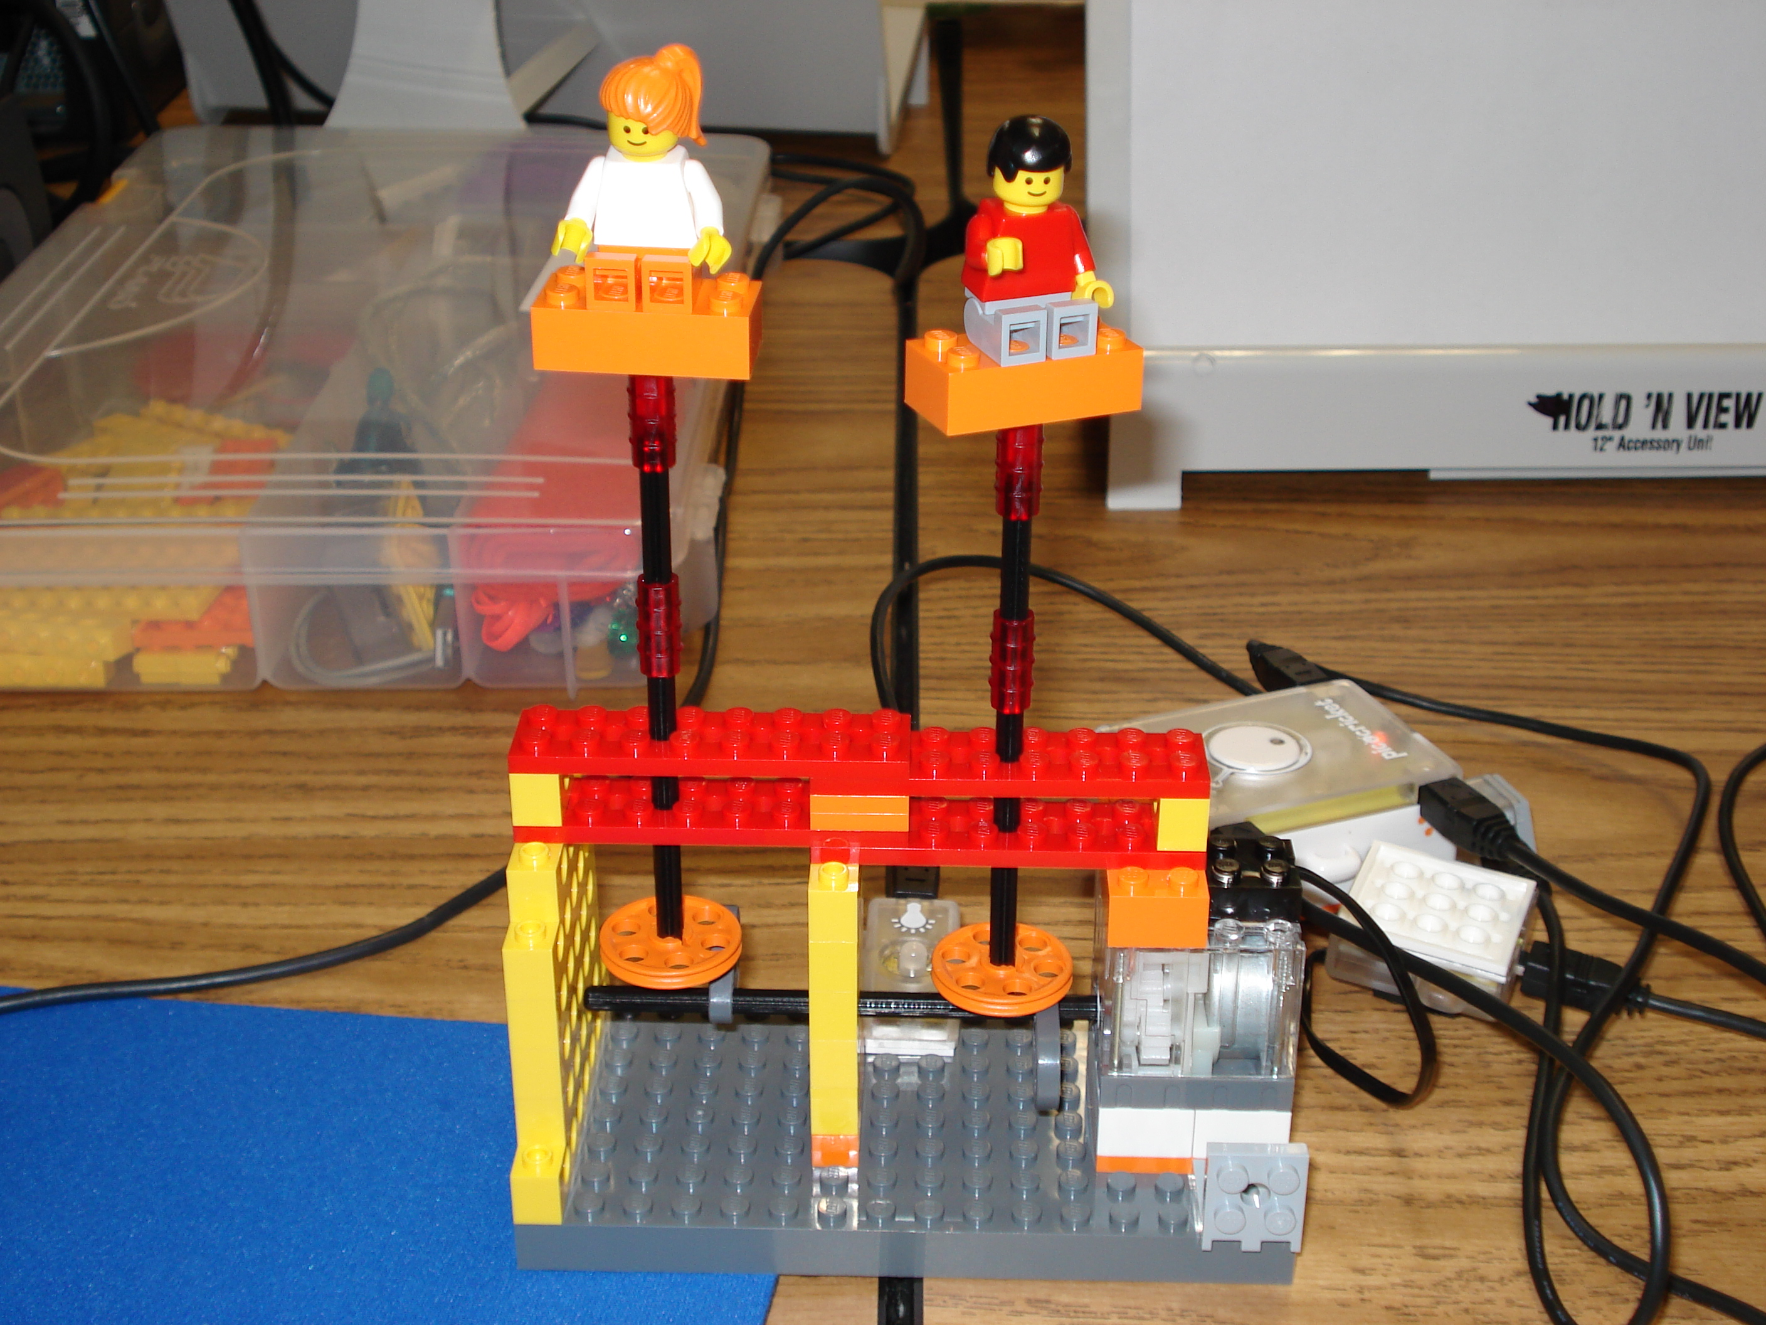
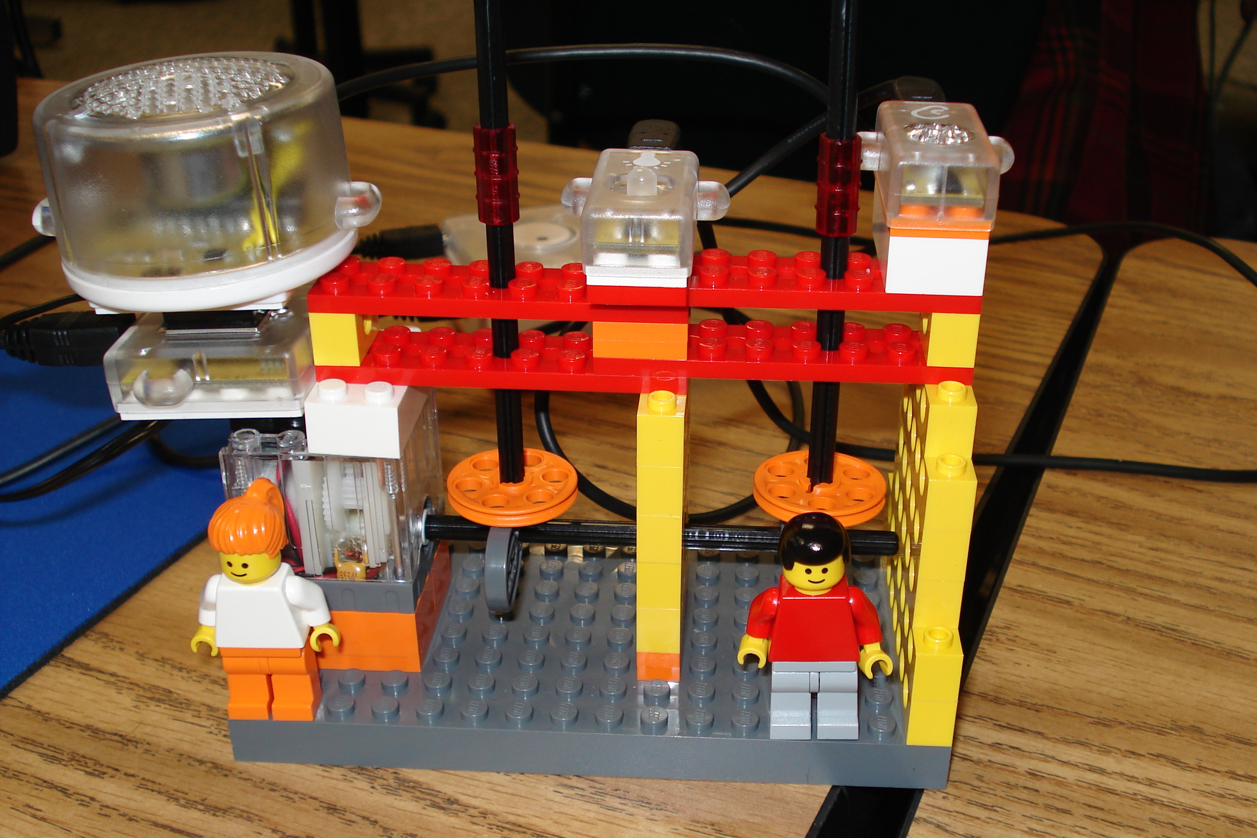
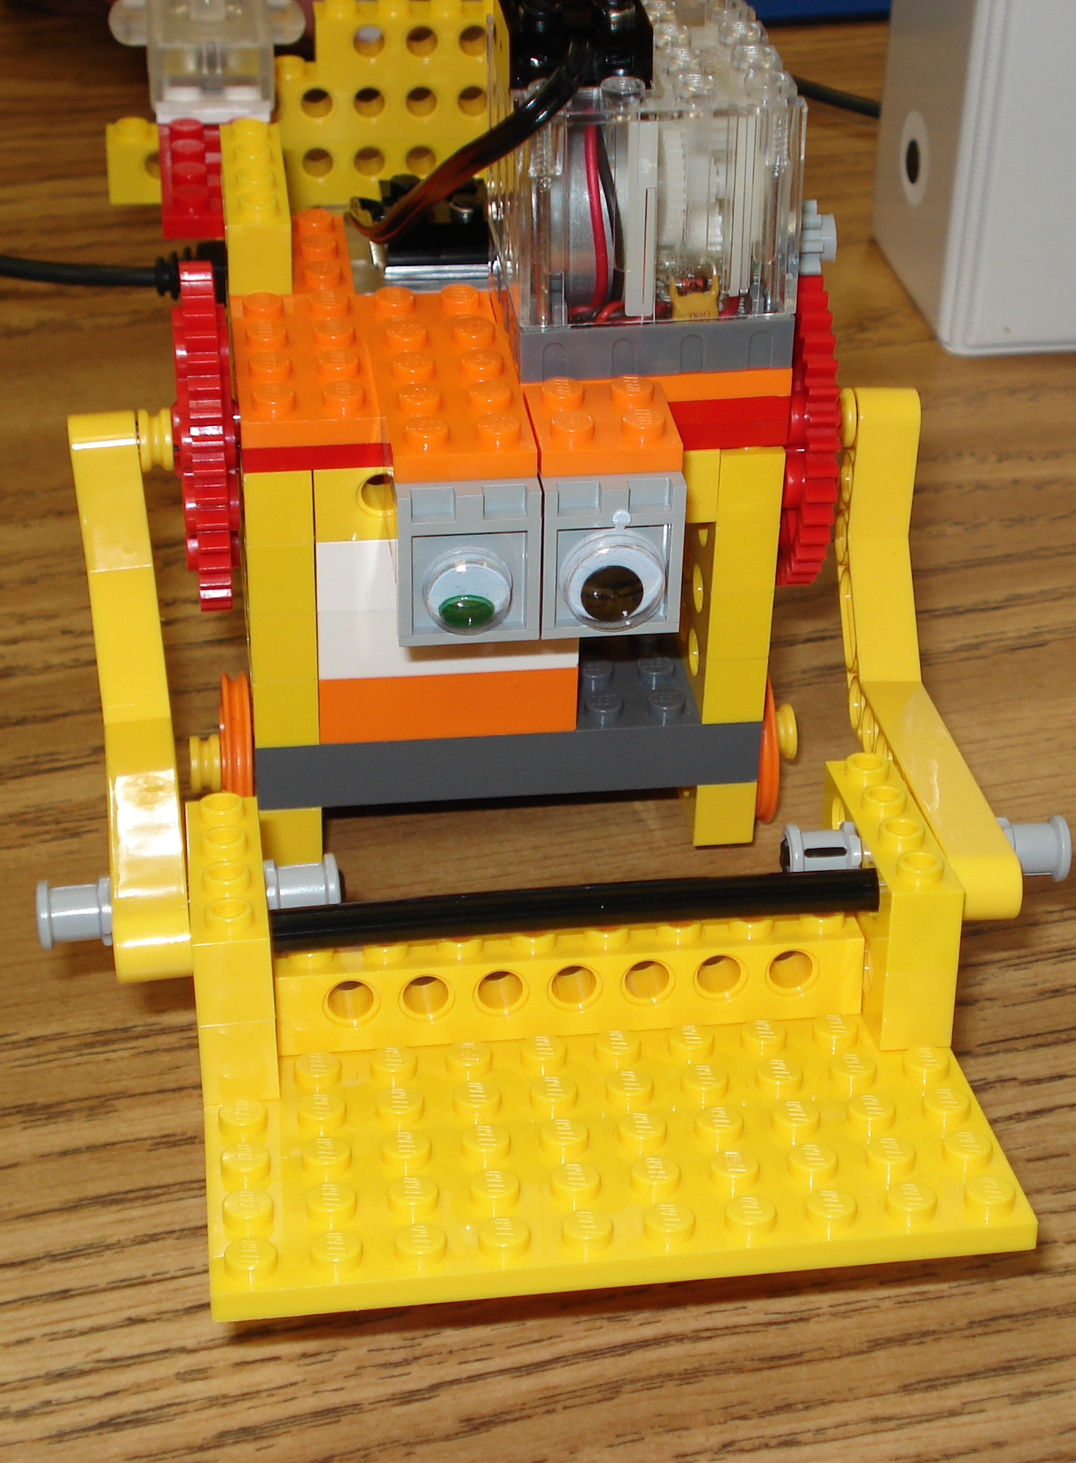
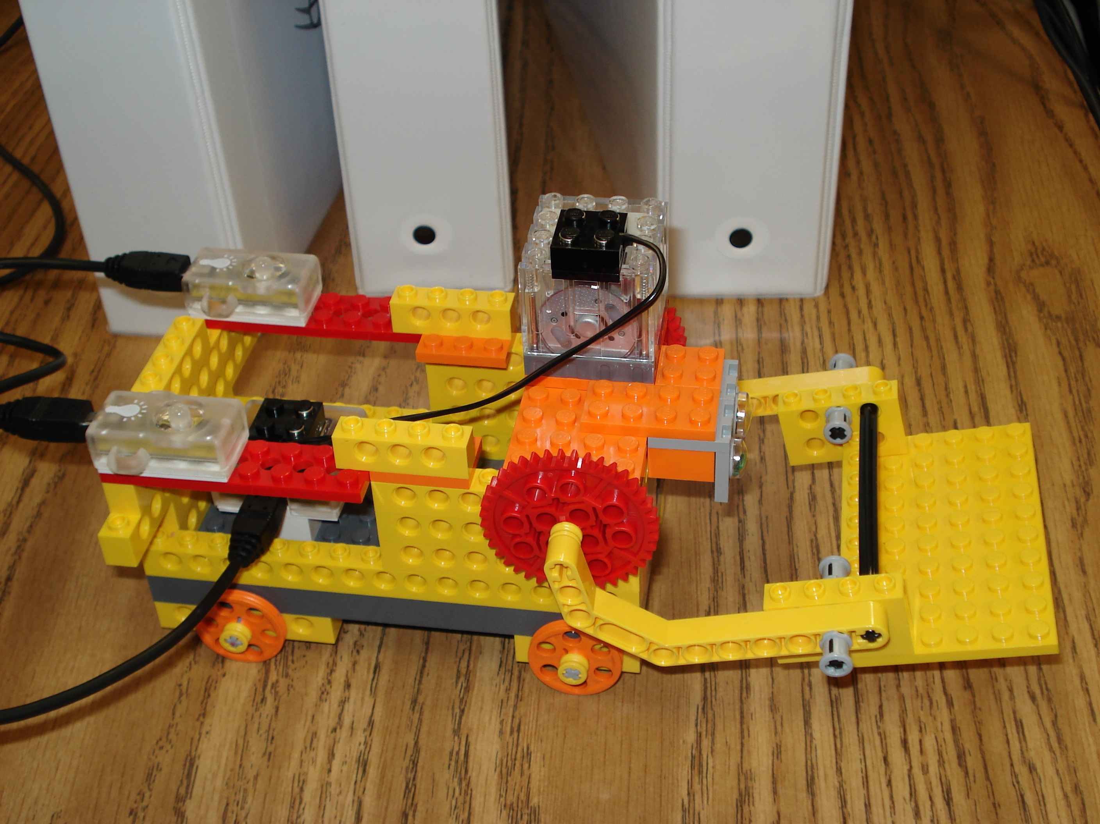
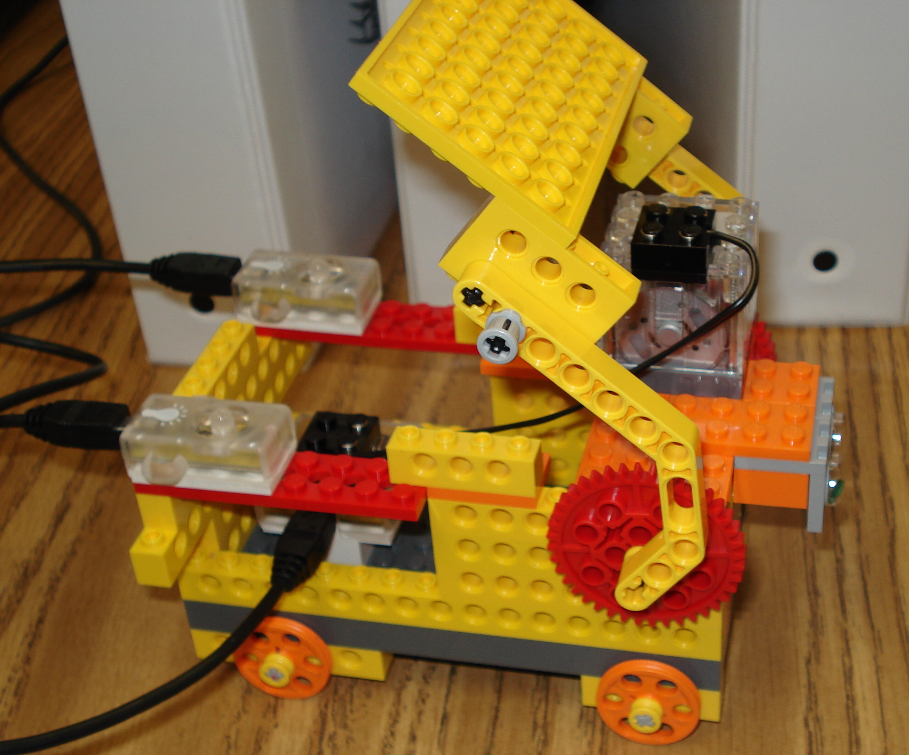
Students in Introduction to Computer Programming created these fantastic projects. The projects were made out of Lego’s and were programmed with the Pico Cricket software program. Models are a helicopter, a dump truck, a catapult and a spinner. .

